URL Structure: https://adityabirlahospital.com/blogs/
Meta Title: Tonsil Surgery in Children | Aditya Birla Memorial Hospital
Meta Description: Learn about tonsil surgery in children—why tonsils are removed, best age for tonsillectomy, recovery tips & how it improves sleep with expert care.
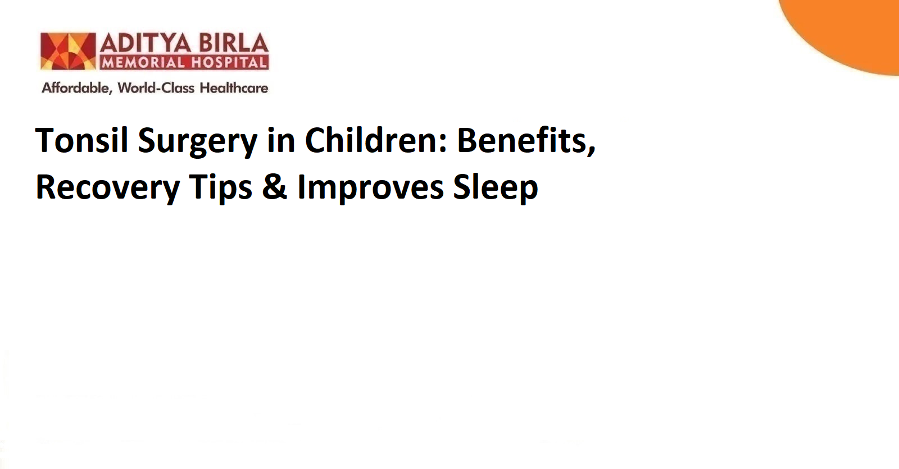
H1: Tonsil Surgery in Children: Benefits, Recovery Tips & Improves Sleep

Why Tonsil Surgery in Children May Be Necessary
Tonsil surgery in children, also known as tonsillectomy, is one of the most common childhood surgeries. The tonsils are two small glands at the back of the throat that help fight infections. When tonsils repeatedly become infected or become too large, they can cause trouble with swallowing, breathing, and even sleeping. Doctors usually suggest surgery when:
- The child has multiple throat infections
- Tonsils stay swollen for long periods
- There are breathing issues, especially during sleep
- Children snore loudly or stop breathing for short moments at night (sleep apnea)
- Persistent bad breath, tonsil stones, or difficulty eating due to swollen tonsils
If these symptoms keep coming back despite treatment, the doctor may recommend a tonsillectomy to help the child feel and breathe better. In this blog, we will look at tonsil surgery in detail.

Best Age to Remove Tonsils: What Parents Should Know
There is no strict age limit, but doctors usually suggest surgery between 3 and 7 years old, as this is often the best age for tonsillectomy. By this time, the immune system is stronger, and kids recover faster. However, tonsillectomy can be performed earlier or later if needed. The decision is based on a child's symptoms, not age alone.

How the Surgery Works: Tonsil Removal Explained
A tonsillectomy is a simple procedure. An otolaryngologist (ENT specialist) performs it. Your child will be given anaesthesia so they are asleep and feel no pain.

During the surgery:
- The tonsils are removed safely from the throat
- The surgery normally takes 20–45 minutes

Kids rest for a few hours afterward and can usually go home the same day.
Parents often worry, but remember — this is a very common and safe surgery when done for the right reasons.

Benefits of Tonsillectomy
Most parents think tonsil surgery is only to prevent infections, but the benefits go beyond that. Tonsil removal can improve a child's overall quality of life.
Benefits include:
- Fewer throat infections
- Less fever, sore throat, and trips to the hospital
- Better appetite and weight gain
- Improved speech in some children
- Better sleep and reduced snoring
- Higher energy levels and better focus in school
Many children with big tonsils struggle to sleep properly and feel tired during the day. After tonsil surgery, they often sleep peacefully, breathe better at night, and wake up fresh.

Recovery Tips & What to Expect at Home
Recovering from tonsil surgery in children takes about 10–14 days. The throat may feel sore, and children may have ear pain or mild fever for a few days.
Helpful care tips:
- Give plenty of cool liquids like water, coconut water, or juices
- Soft foods like yoghurt, smoothies, mashed potatoes, ice cream, and soup are ideal
- Avoid hot, spicy, or crunchy foods
- Ensure rest and avoid heavy activities for at least two weeks
- Pain medicines should be given exactly as prescribed
- Keep the child hydrated to prevent throat dryness
If your child complains more at night, that is normal. But if there is bleeding or the child cannot drink fluids, contact your doctor immediately.

Potential Risks and How to Minimise Them
All surgeries have risks, but complications in tonsillectomy are rare. The most common ones include swelling or slight bleeding. Choosing an experienced doctor and following post-care instructions greatly reduces risks.
Most children recover smoothly and feel much better after healing.

Conclusion
Tonsil surgery in children can make a big difference — fewer infections, better sleep, more energy, and better overall health. If your child struggles with repeated throat infections or breathing issues at night, talk to an ENT doctor to understand the right time and approach.
Consultation with the right expert is important. For guidance and evaluation, reach out to an ENT specialist in Pimpri Chinchwad at the best ENT hospital in Pimpri Chinchwad for proper assessment and care.

FAQs

What exactly is a tonsillectomy, and how is it different from a tonsil operation?
They are the same. Tonsillectomy simply means tonsil operation — the removal of tonsils.

At what age is tonsil removal recommended for children?
Most children get surgery between ages 3–7, but it can be done earlier or later based on symptoms and the doctor’s advice.

What foods and activities should be avoided during the recovery period after tonsillectomy?
Avoid hot, spicy, or crunchy foods, and avoid running or heavy play. Stick to soft foods and plenty of liquids.

How does tonsil surgery help improve sleep and reduce snoring in children?
Large tonsils block airflow. Removing them opens the airway, reducing snoring and helping children breathe and sleep better.

Is there an age limit for tonsil removal in children, and what happens if the surgery is delayed?
There is no strict age limit. Surgery is done when needed. Delaying may lead to frequent infections or sleep issues.

